**MySQL Exercise 1 (31-8-20) Solutions**

**-**V Venkataraman (106118106)

1

-- 1a

CREATE USER 'dbuser'@'localhost' IDENTIFIED BY 'password';

-- 1b

CREATE DATABASE mysampldb;

use mysampldb;

-- 1c

GRANT ALL PRIVILEGES ON mysampldb.EMP TO 'dbuser'@'localhost';

FLUSH PRIVILEGES;

-- Question 3

-- 3a

CREATE TABLE EMP(

EMPNO int(6),

ENAME varchar(20) NOT NULL,

JOB varchar(10) NOT NULL,

DEPTNO int(3),

SAL double(7,2)

);

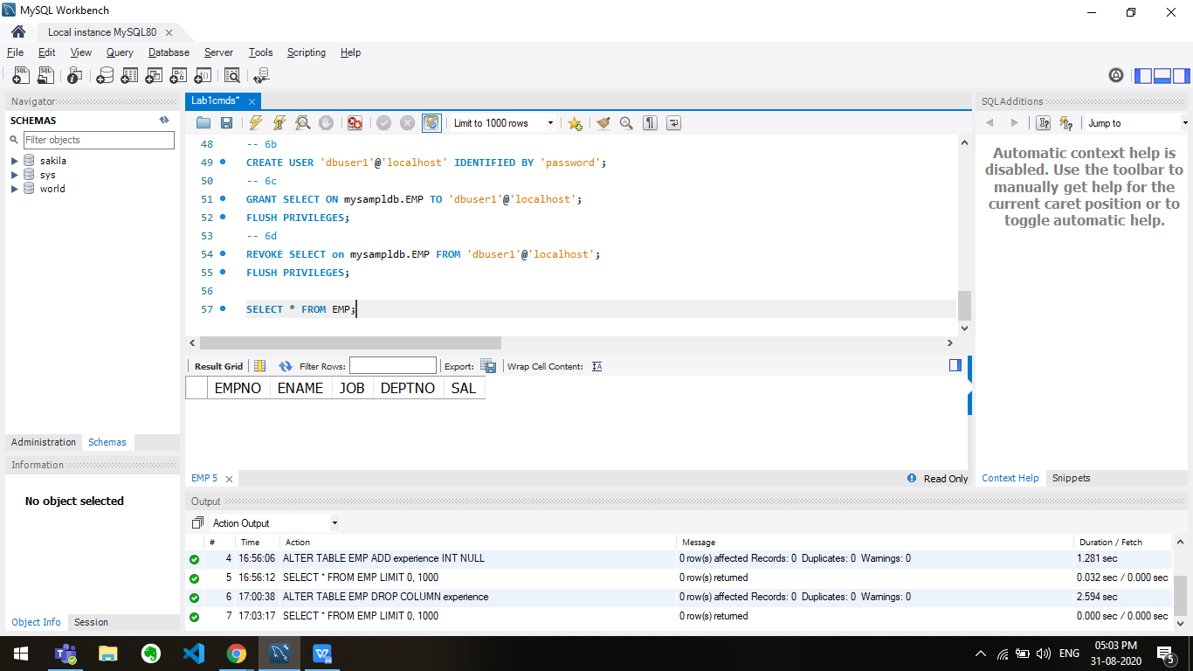

-- 3b

ALTER TABLE EMP ADD experience INT NULL;

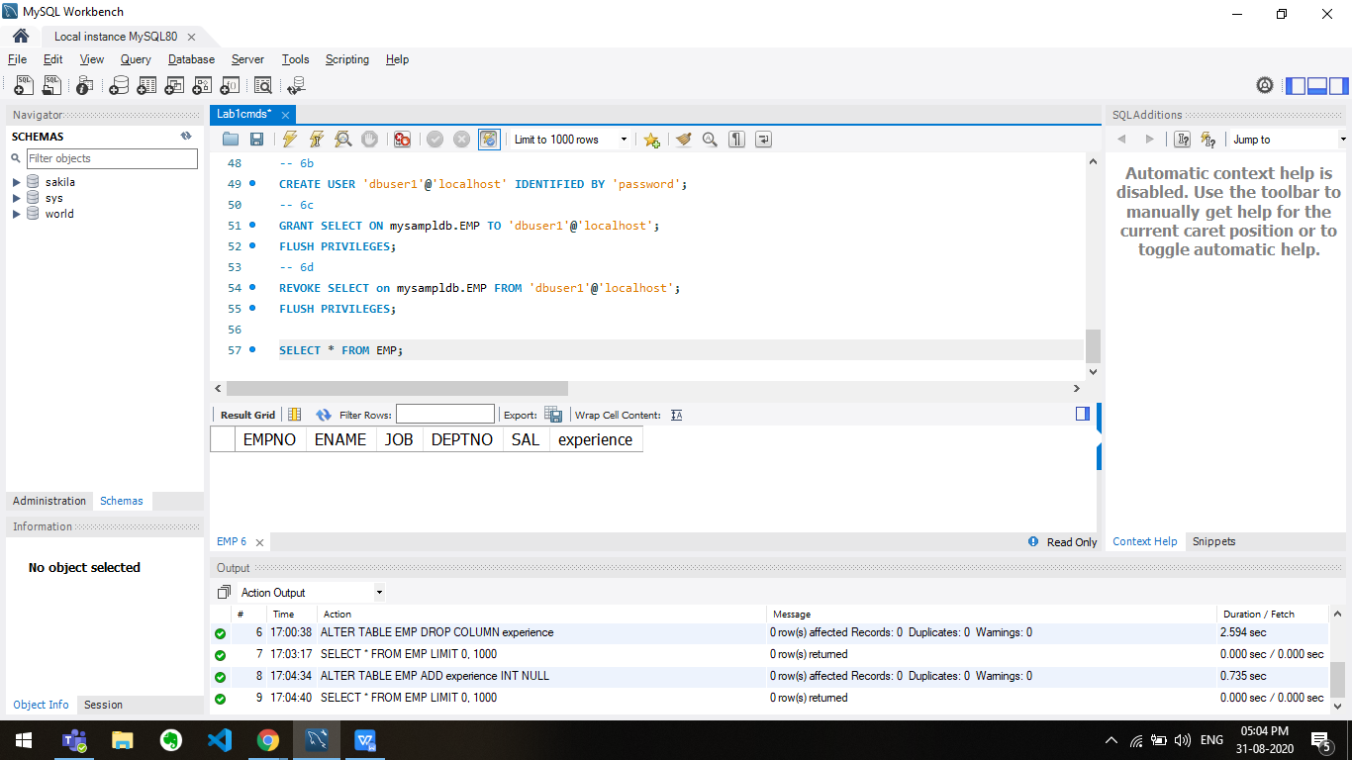

-- 3c

ALTER TABLE EMP MODIFY COLUMN JOB varchar(30) NOT NULL;

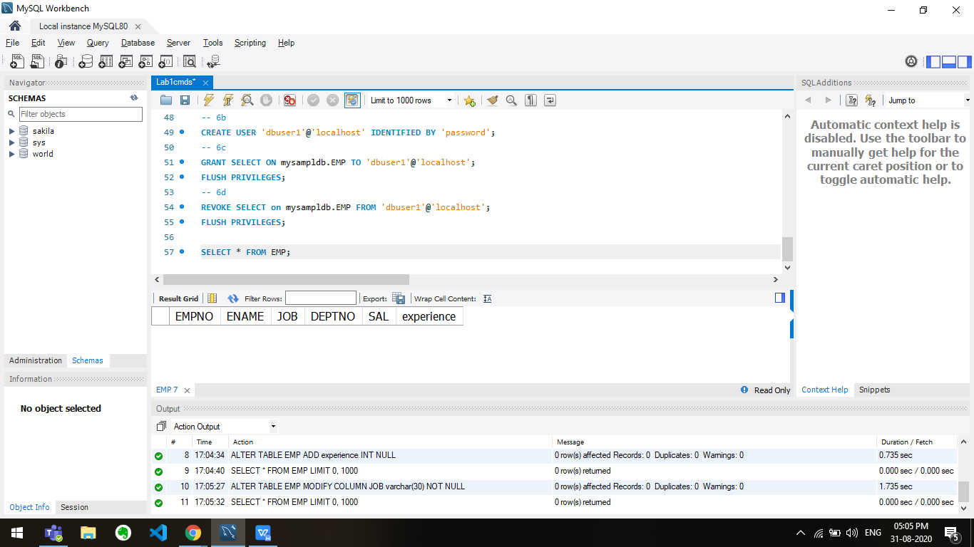

-- 3d

CREATE TABLE dept(

DEPTNO int(2),

DNAME varchar(10),

LOC varchar(10)

);

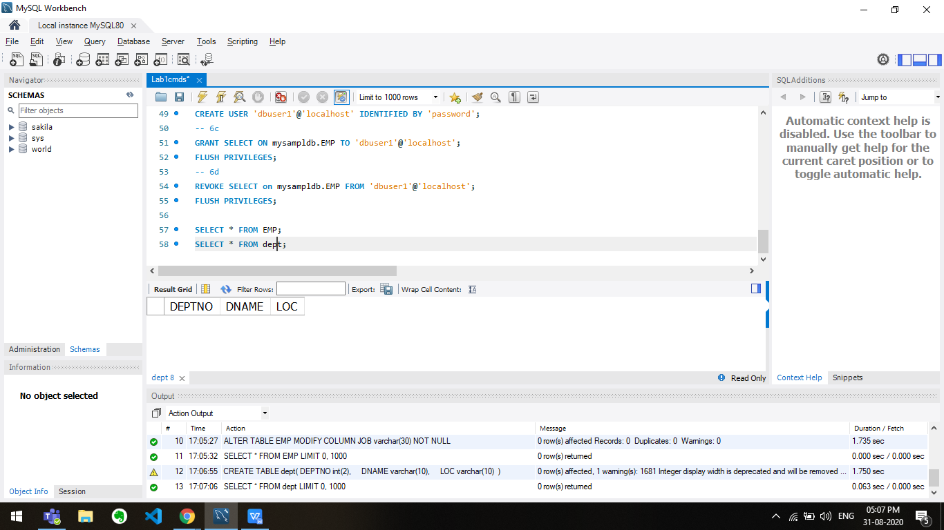

-- 3e

ALTER TABLE EMP DROP COLUMN experience;

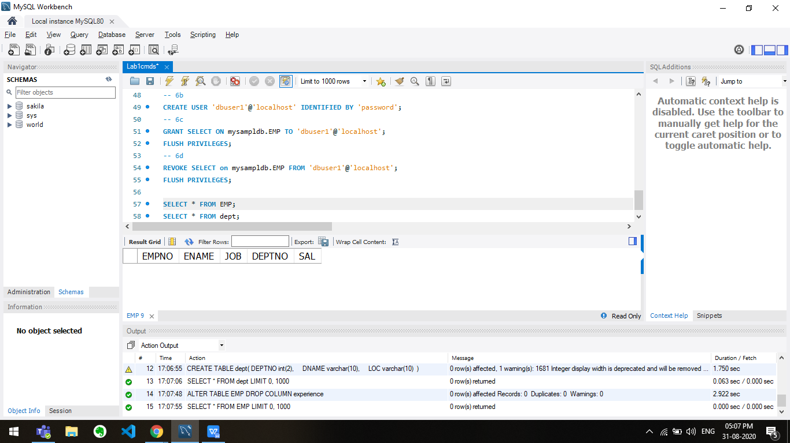

-- Question 4

-- 4a

INSERT INTO dept VALUES(106, "CSE", "East");

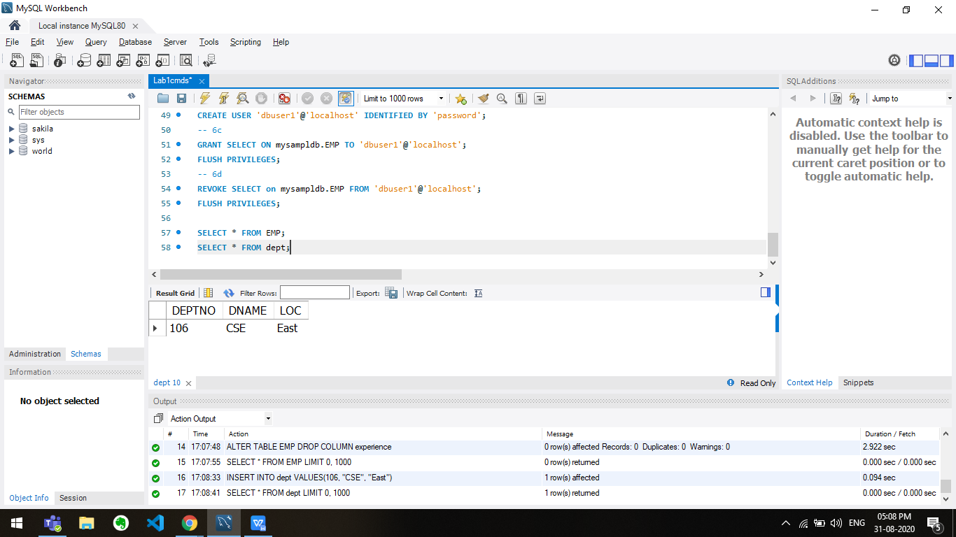

-- 4b

INSERT INTO EMP VALUES (1001,"Alice","Manager",2, 10000.00), (1002,"Bob","Engineer",8, 50000.00), (1003,"Charlie","Sales",5, 5000.00);

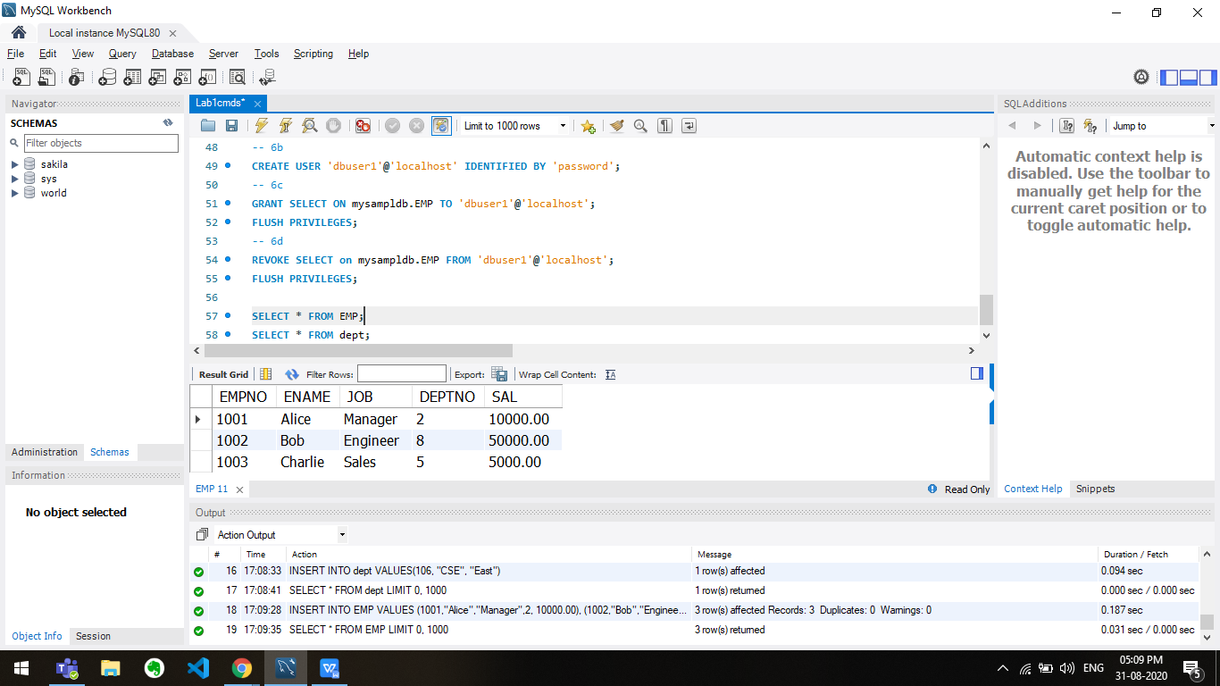

-- 4c

SELECT ENAME, JOB from EMP;

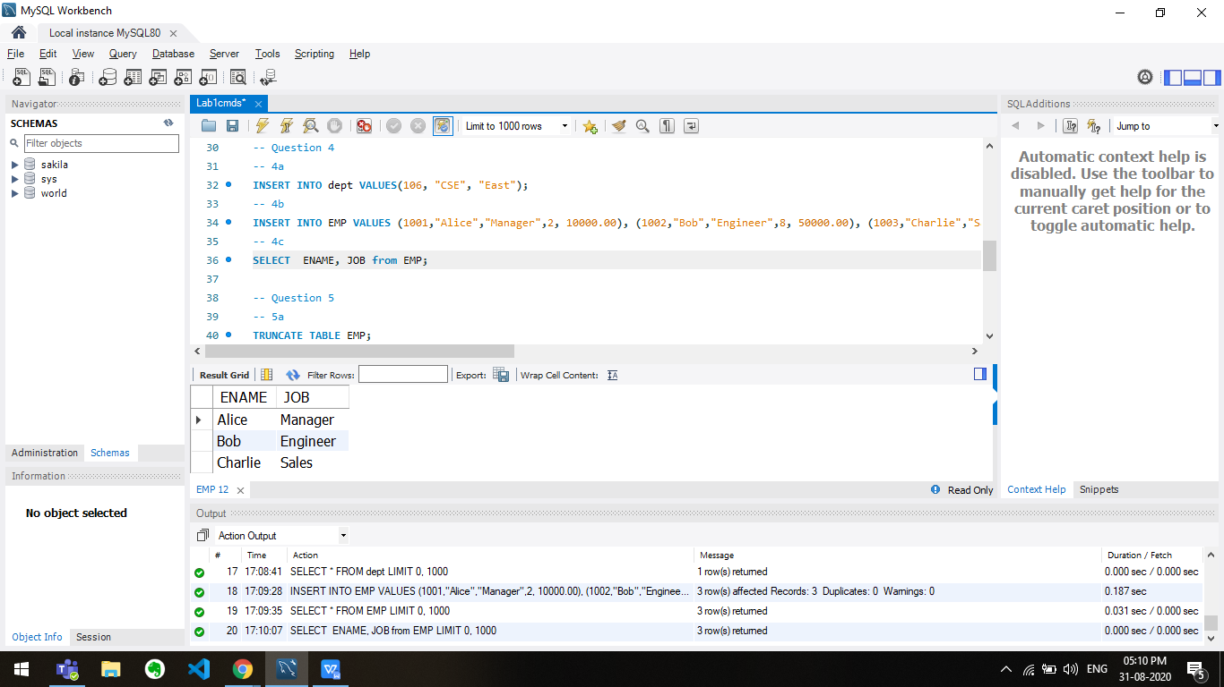

-- Question 5

-- 5a

TRUNCATE TABLE EMP;

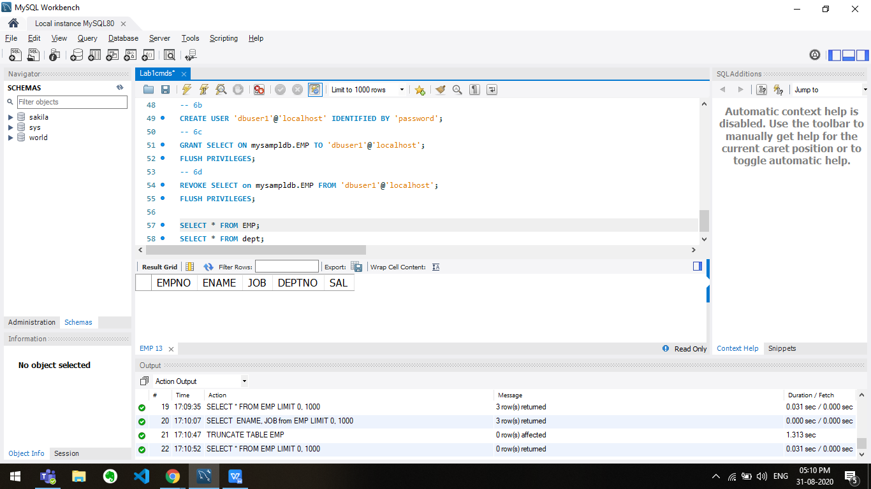

-- 5b

DROP TABLE dept;

-- Question 6

-- 6a

REVOKE ALL PRIVILEGES on mysampldb.EMP FROM 'dbuser'@'localhost';

FLUSH PRIVILEGES;

-- 6b

CREATE USER 'dbuser1'@'localhost' IDENTIFIED BY 'password';

-- 6c

GRANT SELECT ON mysampldb.EMP TO 'dbuser1'@'localhost';

FLUSH PRIVILEGES;

-- 6d

REVOKE SELECT on mysampldb.EMP FROM 'dbuser1'@'localhost';

FLUSH PRIVILEGES;